

**CLOTHING SHOP Project Report**

**Software Requirement Specification**

– Hanoi, Summer 2022 –

Contents

1. Introduction 3

1.1 Purpose 3

1.2 Document Conventions 3

1.3 Project Scope 3

1.4 References 3

2. Overall Description 3

2.1 Product Perspective 3

2.2 User Classes and Their Use Cases 4

2.2.1 Visitor 4

2.2.2 Customer 4

2.2.3 Seller 4

2.2.4 Administrator 4

2.3 Operating Environment 5

2.4 Dependencies 5

Dependencies: 5

2.5 Business rules (Updating…) 5

3. Functional Requirements 5

3.1 System Functional Overview 5

**3.4****View Product Detail** 13

**3.5****Change Amount** 14

**3.6****Delete Product** 15

**3.7****Register** 16

4. Data Requirements 17

4.1 Logical Data Model (Updating…) 17

4.2 Data Dictionary (Updating…) 17

4.4 Data Integrity and Retention 17

5. External Interface Requirements 17

5.1 User Interfaces 17

The Clothing Shop Ordering System screen displays shall conform to the User Interface Design and User Experience Design 17

5.2 Software Interfaces (Updating…) 17

5.3 Hardware Interfaces 17

5.4 Communications Interfaces 17

6. Nonfunctional Requirements 18

6.1 Performance Requirements 18

6.2 Security 18

7. Other Requirements 18

Appendix A: Analysis models 19

Context Diagram 19

State Transition Diagram for Order 19

# Introduction

## Purpose

This document describes the requirements for website, which provides services and supplies clothes for purchaser. Types of reader this document is intended for: developers, project managers, testers, customers, etc...

## Document Conventions

The functional requirements for this project are organized by users.

## Project Scope

The website will provides common information clothes for the customers. This website also will permit purchasers to pick up clothes from the company online to be delivered to specified locations.

## References

Existing web sites used as models for ideas regarding the functionality documented and user interface style here include:

* https://www.zanado.com
* http://www.viviane.vn
* http://www.yes24.vn
* http://www.penda.vn

# Overall Description

## Product Perspective

The 4.0 revolution is approaching, that's why information technology has been playing a huge role today , and it will be a challenge when an organization or any area of life lacks a computer system. Online shopping is a trend that provides all the details about customers, products, orders, etc… Specifically, this Online Shopping System is a kind of online shop where a seller can sell his/her products or services and customers can buy. Selling online has been easier, faster, or more convenient than with traditional selling.. We have developed this mini project Online Shopping System on Java, JSP, and SQL, all HTML code will conform to the HTML 5.0 standard and the project will runs over the Glassfish 4.1.1 Server. In case something bad happens, including system failure or negative feedback,… the administrator will be able to maintain and modify the site. This system supports the below types of user… (see more in section 2.2)

## User Classes and Their Use Cases

### Visitor

A visitor is someone who visit the website to learn more information about clothes sold on this website. Use cases:

1: View all products

2: Search for a product

3: View product’s detail

4: Read blog

### Customer

A customer is someone who orders a product from the website. Use cases:

1: Login

2: View all products

3: Search for a product

4: View product’s detail

5: Add product to cart

6: Checkout

7: Check order status

8: Cancel order

9: Rate product

10: Give feedback

11: Read blog

### Seller

A seller is someone who has the responsibilities to manage the website’s products and the business important data

1: Create a product

2: Modify a product

3: Delete a product

4: Add promotion detail

5: View dashboard

### Administrator

An administrator is the person who has the responsibility to manage users of website. Use cases:

1: Change users’ information

2: Delete an user

## Operating Environment

The website will be compatible with standard web browsers on Computer and Smart Phone platforms.

## Dependencies

## Dependencies:

* User’s environment (Browser)
* User’s devices (Computer, Smart phone,…)
* External libraries

## Business rules

|  |  |  |  |  |
| --- | --- | --- | --- | --- |
| ID | Rule definition | Type of rule | Static or dynamic | Source |
| BR-1 | Deliveries must be completed in 1 week after the order approved | Constraint | Dynamic | Shop policy |
| BR-2 | All goods in a single order must be paid for by using the same payment method. | Constraint | Static | Shop manager |
| BR-3 | Only sellers can create, modify, or delete products. | Constraint | Static | Shop manager |
| BR-4 | Only administrators can modify, or delete users. | Constraint | Static | Shop manager |
| BR-5 | Order price is calculated as the sum of each order item price times the quantity of that order item ordered, plus shipping fee | Computation | Dynamic | Shop manager |

## 3. Functional Requirements

### 3.1 System Functional Overview

#### a. Screen Flow

User

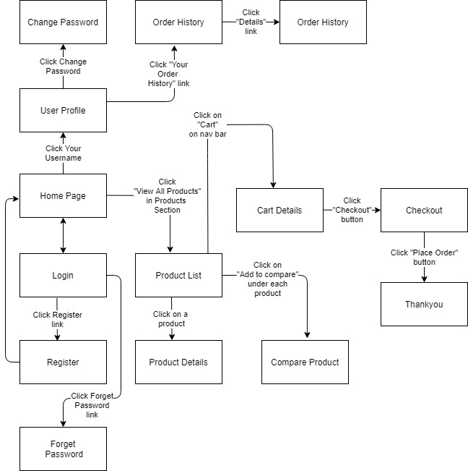

Figure 1-1: Screen Flow for User

Admin

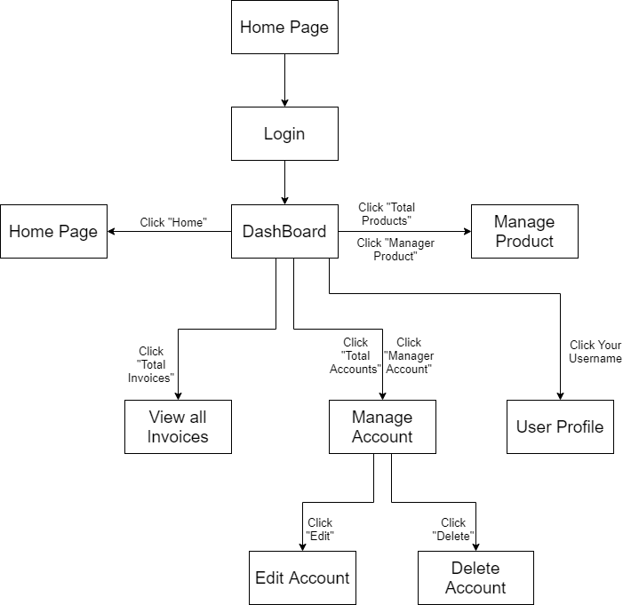

Figure 1-2: Screen Flow for Admin

Seller

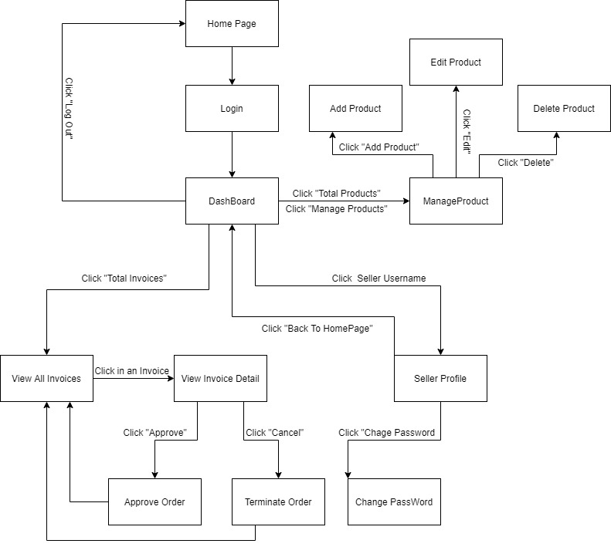

Figure 1-3: Screen Flow for Seller

#### b. Screen Details

|  |  |  |  |
| --- | --- | --- | --- |
| **#** | **Feature** | **Screen** | **Description** |
|  | Search & Filter Product | Home Page | Search for a Product by name or filter it by category |
|  | View Product Detail | Product Details | Display detail information of Product |
|  | Change Amount | Cart Details | Plus or Minus the Amount of a Product in Cart |
|  | Delete Product | Cart Details | Delete a Product in Cart |
|  | Delete Cart | Cart Details | Delete all the Product in Cart |
|  | Login | User Login | User Login to the System |
|  | Register | User Register | User Register for an account |
|  | View User List | Users List [Admin] | Admin View the list of all Accounts in the System |
|  | Edit User | Users List [Admin] | Admin Edit information of an Account |
|  | Delete User | Users List [Admin] | Admin Delete an Account from the System |
|  | Add Ship Information | Cart Completion | User enter all shipping information for delivery |
|  | Change Ship Information | Cart Completion | User can change the existing shipping information for delivery |
|  | Reset Password | Reset Password | When user forget password, send a verification code through Email for user to reset password |
|  | Change Password | Change Password | Change user’s old password with new password |
|  | User Profile | User Profile | User views information about his account |
|  | My Orders | My Orders | User views the history of all orders he made |
|  | Order Information | Order Information | User views detail history of a specific order |
|  | View Product List | Products List [Sale] | Seller views all of Products that he sells |
|  | Orders List | Orders List [Admin] | Admin views list of all of 2orders |
|  | Order Details | Order Details [Sale] | Seller views the detail of 1 of his orders |
|  | View Feedback | Feedback | Customer views all the Feedbacks about a Product |
|  | Send Feedback | Feedback | Customer writes and send a Feedback about a Product |
|  | Blogs List | Blogs List | Customer views the list of all Blogs |
|  | Blog Details | Blog Details | Customer views the Detail information of 1 Blog |
|  | View Notification | Notification | User views the list of new Notifications |
|  | View all Notification | Notification | User views the list of all Notifications |
|  | Mark as Read | Notification | User mark all the new Notification as read |
|  | Error | Error | Show in case there’s an Error occurs |

Table 1-1: Screen Details

#### c. Screen Authorization

| **Screen** | **Guest** | **User** | **Seller** | **Admin** |
| --- | --- | --- | --- | --- |
| Home Page | x | x |  |  |
| Product Details | x | x |  |  |
| Cart Details |  | x |  |  |
| User Login | x |  |  |  |
| User Register | x |  |  |  |
| User Authorization | x |  |  |  |
| Users List [Admin] |  |  |  | x |
| Cart Completion |  | x | x | x |
| Reset Password |  | x | x | x |
| Change Password |  | x | x | x |
| User Profile |  | x | x | x |
| My Orders |  | x |  |  |
| Order Information |  | x |  |  |
| Products List [Admin] |  |  |  | x |
| Orders List [Sale] |  |  | x |  |
| Order Details [Sale] |  |  | x |  |
| Feedback | x | x |  |  |
| Blogs List | x | x |  |  |
| Blog Details | x | x |  |  |
| Notification |  | x | x | x |
| Error | x | x | x | x |

In which:

* Guest: Customer who has not yet logged in to the site
* User: Customer who has an account an has logged in
* Seller: People who sell products in the shop
* Admin: People who manage the shop

#### d. Non-Screen Functions

|  |  |  |  |
| --- | --- | --- | --- |
| **#** | **Feature** | **System Function** | **Description** |
| 1 | Remember Me | Login | System store user’s login account and password in cookies for future re-login |
| 2 | Add To Cart | Home Page & Product Detail | User Click “Add To Cart” to add this Product to Cart |

#### e. Entity Relationship Diagram

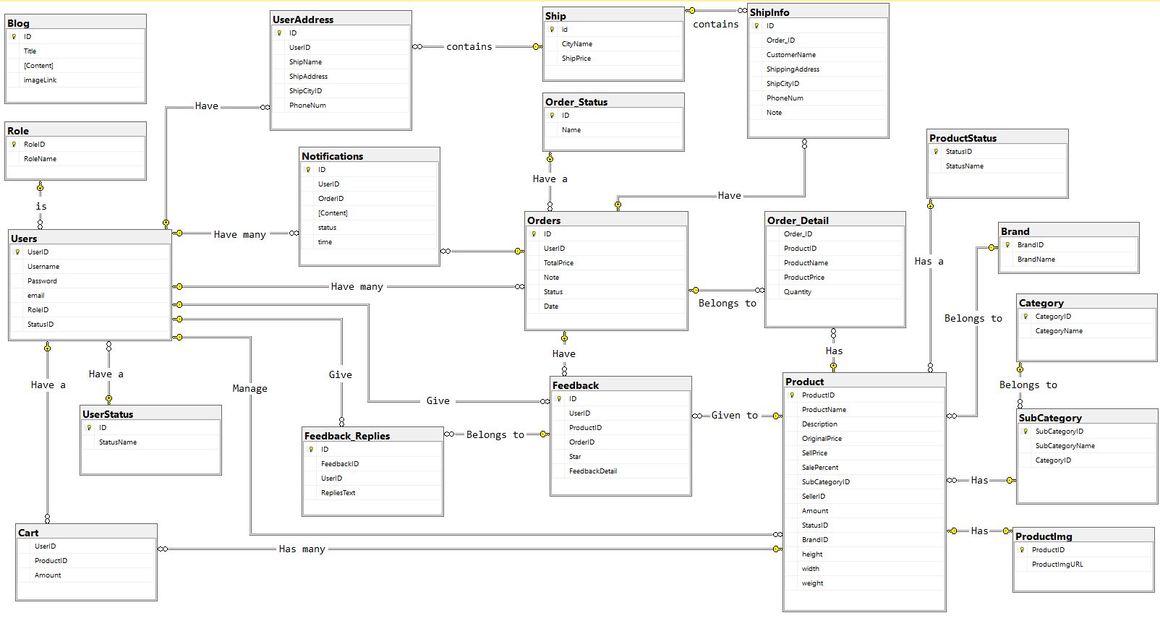

**Entities List**

|  |  |  |
| --- | --- | --- |
| **#** | **Entity** | **Description** |
| 01 | Blog | Store the blogs |
| 02 | Role | Customers or Sellers or Admin |
| 03 | Users | Store the information of all users (including customers, sellers and admin) |
| 04 | UserStatus | Store status value of user |
| 05 | Cart | Store information of the Cart (a list of product) of each Customer |
| 06 | UserAddress | Store the default shipping address of user (user can change this information) |
| 07 | Notifications | Store all of notifications of all users (customers, sellers, admin) |
| 08 | Feedback_Replies | Store the replies of admin/ moderator of the website to the customers feedbacks |
| 09 | Ship | Store the price of ship for each City |
| 10 | Order_Status | Store the status value of the order |
| 11 | Orders | Store the information about orders |
| 12 | Feedback | Store the rating of every product from the customer after buying |
| 13 | ShipInfo | Store the information of the order (including shipping address, shipping price, phone number of customer…) |
| 14 | Order_Detail | Store information about detailed shopping in every order. |
| 15 | Product | Store the information of all products |
| 16 | ProductStatus | Store the status value of the product |
| 17 | Brand | Store the manufacturer name of the product |
| 18 | SubCategory | Store the information of SubCategories of products |
| 19 | ProductImg | Store the image of product |
| 20 | Category | Store the information of Categories of products |

**3.2 Search & Filter Product**

* Function trigger: User accesses the website
* Function description:
  + Role: Guest, User
  + Purpose: Users Search for the Product they want
* Screen layout: 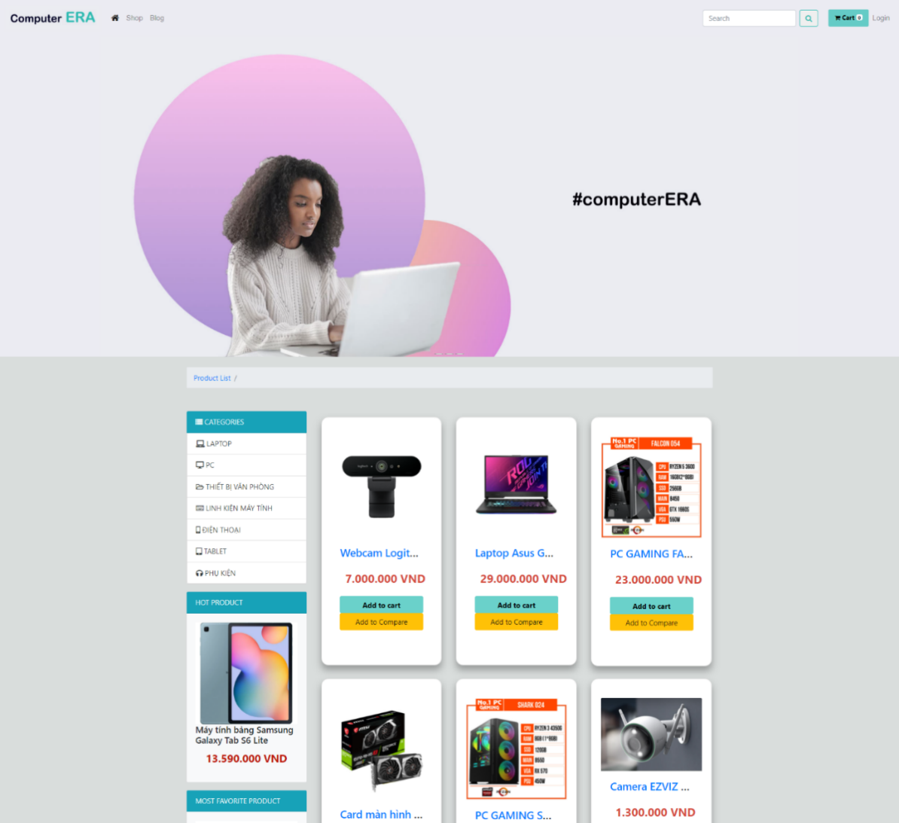

**3.3 View Product Detail**

* Function trigger: User Click on a Product in Home Page
* Function description:
  + Role: Guest, User
  + Purpose: User can view all the detail information of a Product
* Screen layout:

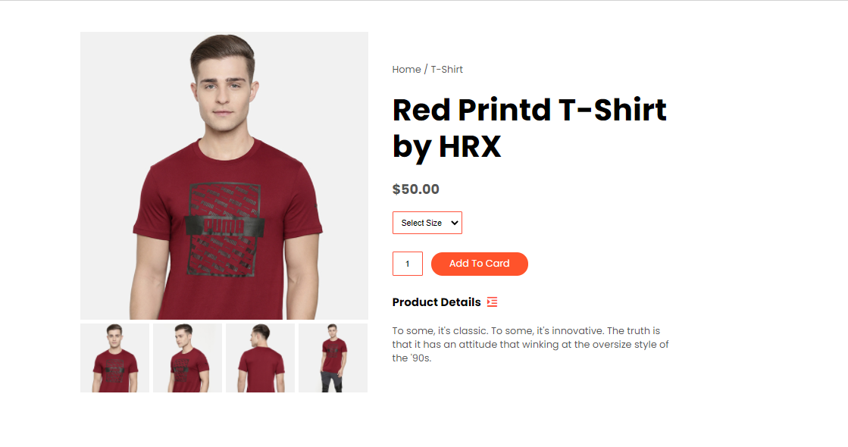

* 1. **Change Amount**
* Function trigger: User Click on “Cart” in Menu bar
* Function description:
  + Role: User
  + Purpose: User can change the amount of the Product they want to buy
* Screen layout: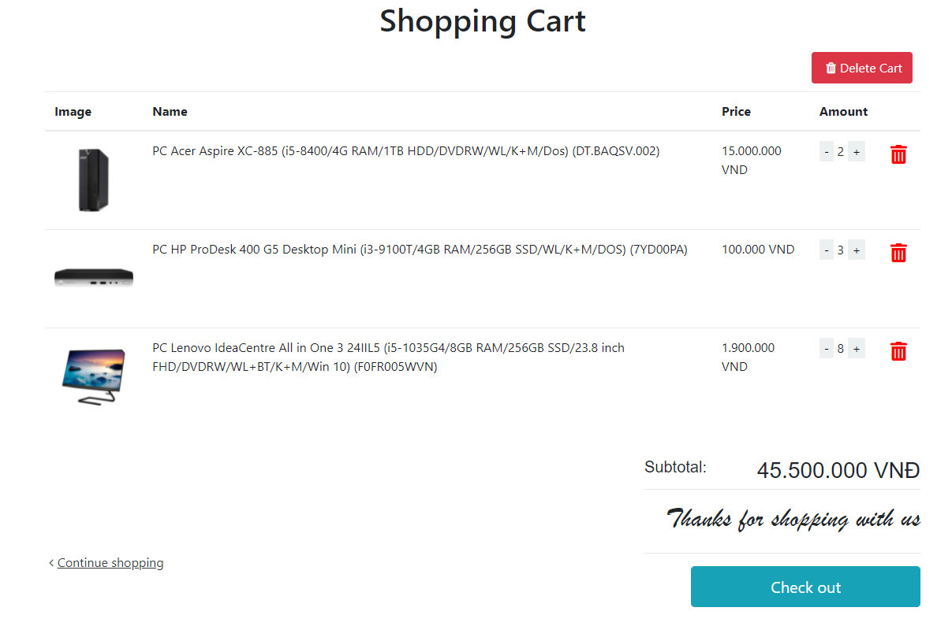
  1. **Delete Product**
* Function trigger: User Click on the Delete icon in a Product in Cart
* Function description:
  + Role: Guest
  + Purpose: User can Delete a Product from their Cart
* Screen layout:

**

* 1. **Delete Cart**
* Function trigger: User Click on “Delete Cart” button in Cart
* Function description:
  + Role: User
  + Purpose: User can delete all the Product in their Cart
* Screen layout:

**

* 1. **Login**
* Function trigger: User Click on “Login” link in the Menu bar
* Function description:
  + Role: Guest
  + Purpose: For people to log in to the system for access to more functions
* Screen layout: 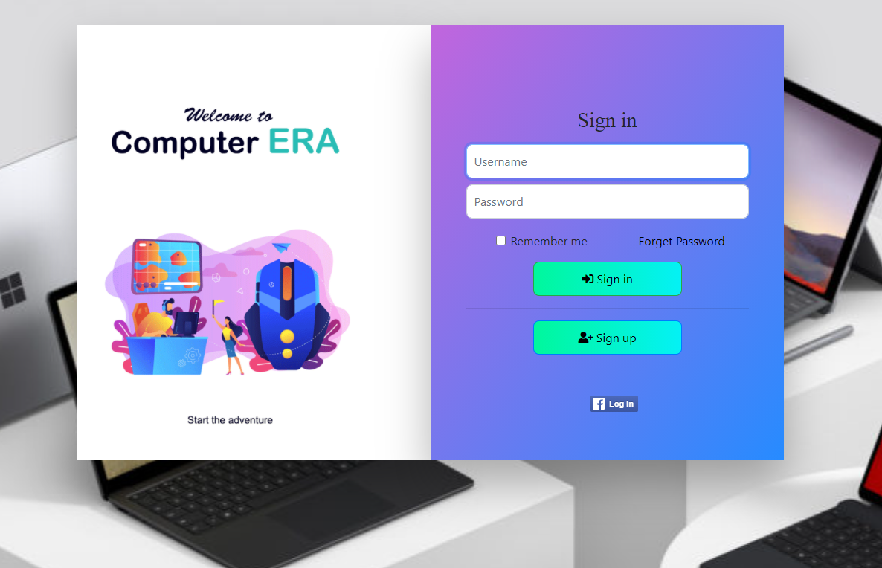
  1. **Register**
* Function trigger: Guest click “Sign up” button from Login screen.
* Function description:
  + Role: Guest.
  + Purpose: Provide a form for customer to register an account.
* Screen layout:

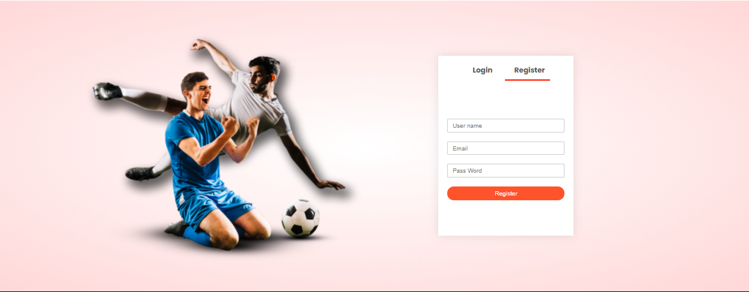

* 1. **View User List**
* Function trigger: Admin click on “Total Account” card or “Manager Account” link from Admin Dashboard.
* Function description:
  + Role: Admin.
  + Purpose: View list of all account.
* Screen layout:

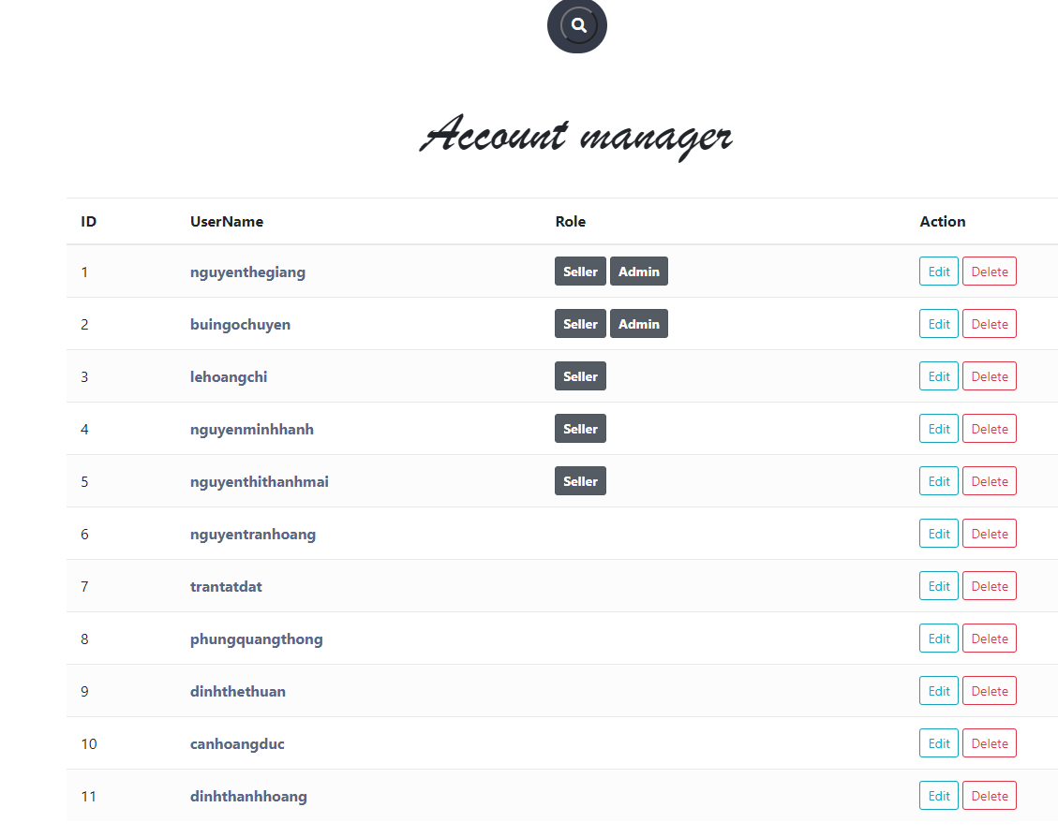

* 1. **Edit User**
* Function trigger: Admin click “Edit” button next to an entry from user list.
* Function description:
  + Role: Admin.
  + Purpose: Edit information of an account.
* Screen layout:

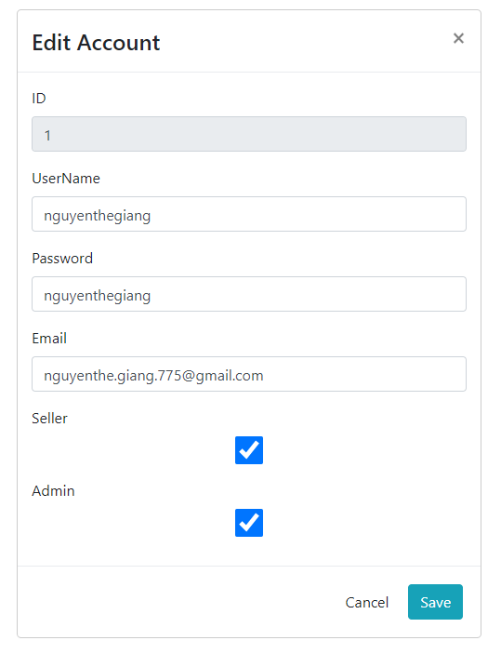

* 1. **Delete User**
* Function trigger: Admin click “Delete” button next to an entry from user list.
* Function description:
  + Role: Admin.
  + Purpose: Delete an account from the system.
* Screen layout:

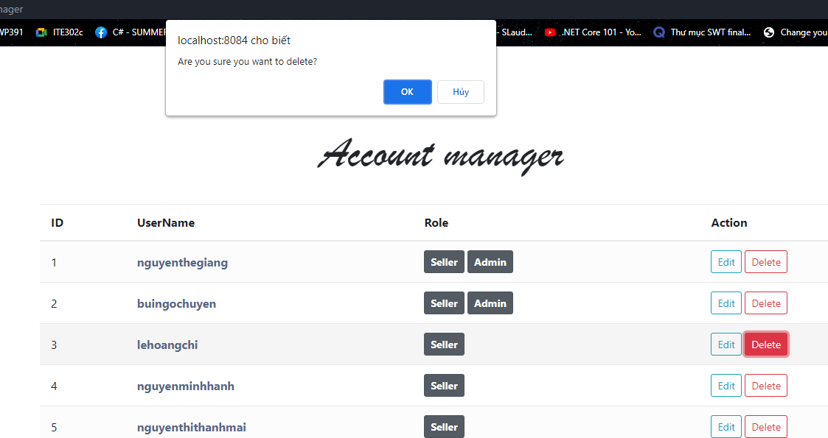

* 1. **Add Ship Information**
* Function trigger: When a customer click the checkout button from cart but the user has no default shipping address.
* Function description:
  + Role: Customer.
  + Purpose: Add a default shipping information.
* Screen layout:

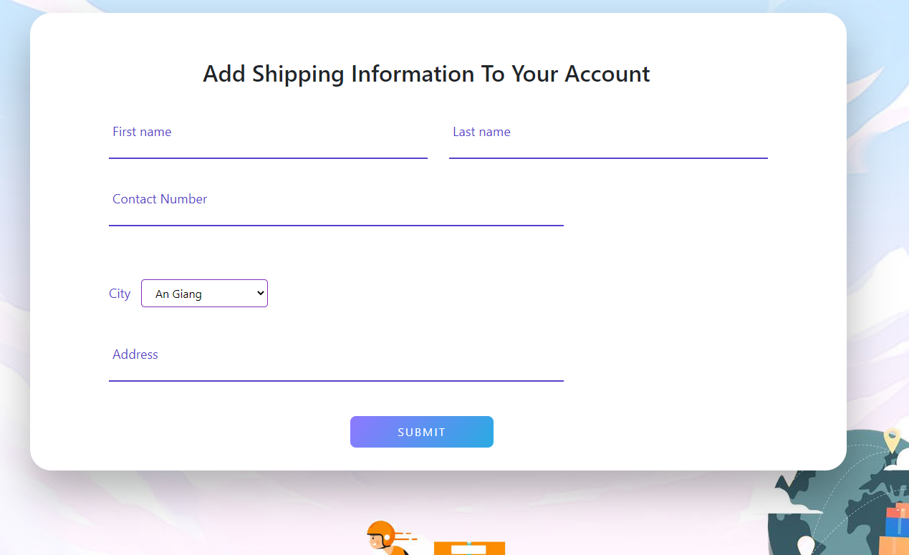

* 1. **Change Ship Information**
* Function trigger: Customer click the “Change shipping information” when he/she wants to ship the order to a different address from his/her default address.
* Function description:
  + Role: Customer.
  + Purpose: Enter a different shipping information for an order.
* Screen layout:

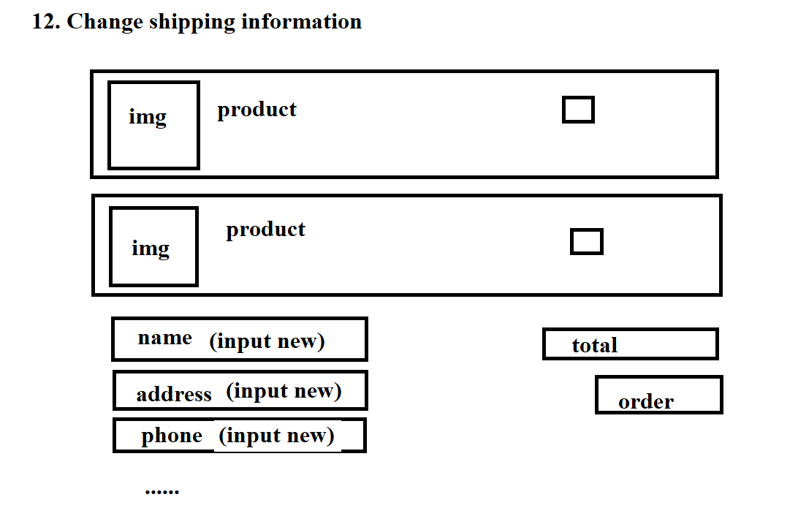

* 1. **Reset Password**
* Function trigger: Users access the website and click on Reset Password button
* Function description:
  + Role: Buyer, Seller, Admin
  + Purpose: Users can change their passwords when they forget their old one
* Screen Layout:

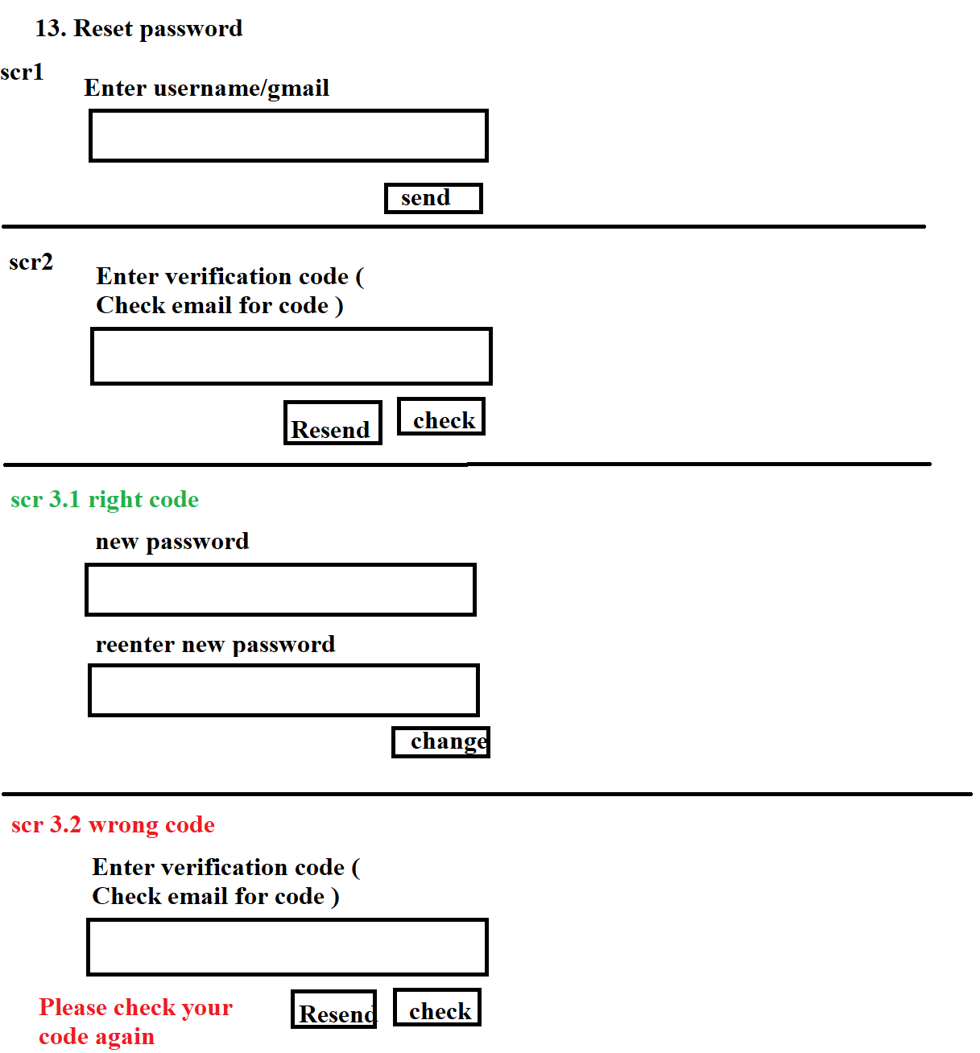

* 1. **Change Password**
* Function trigger: Users login the website and access the profile page and click on Change Password button
* Function description:
  + Role: Buyer, Seller, Admin
  + Purpose: Users can change their passwords
* Screen Layout:

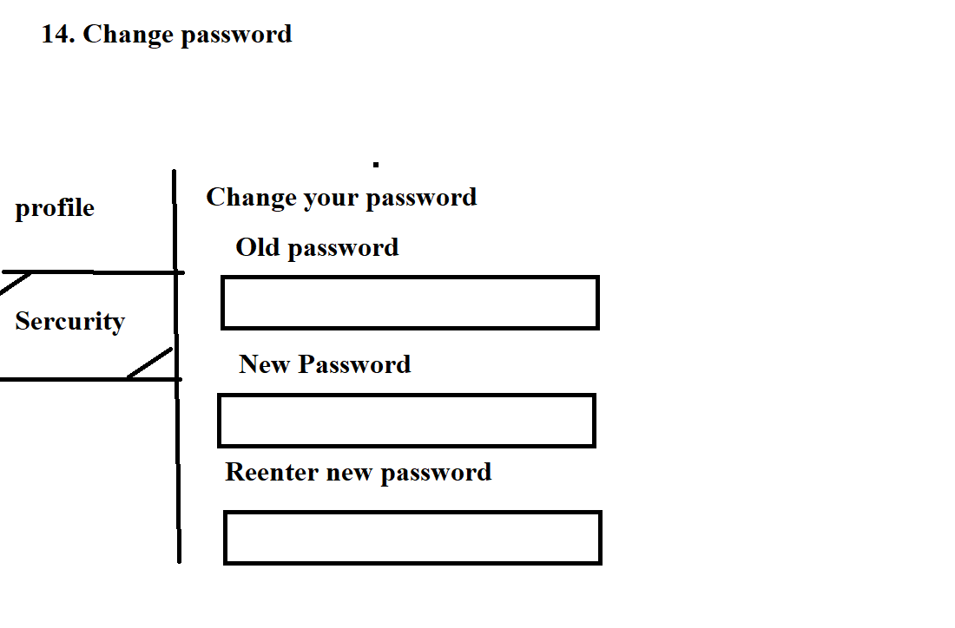

* 1. **User Profile**
* Function trigger: User log-in the website and click on the profile icon on the top-right corner
* Function description:
  + Role: Buyers, Seller, Admin
  + Purpose: Users can see their account’s detailed information
* Screen layout:

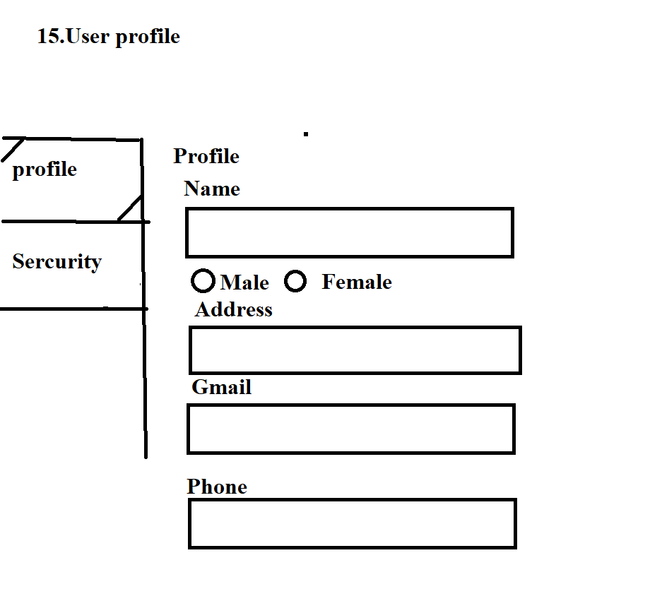

* 1. **My Orders**
* Function trigger: Users log-in the website, access the profile page and click on My Orders button
* Function description:
  + Role: Buyers
  + Purpose: Users can see their shopping history
* Screen layout:

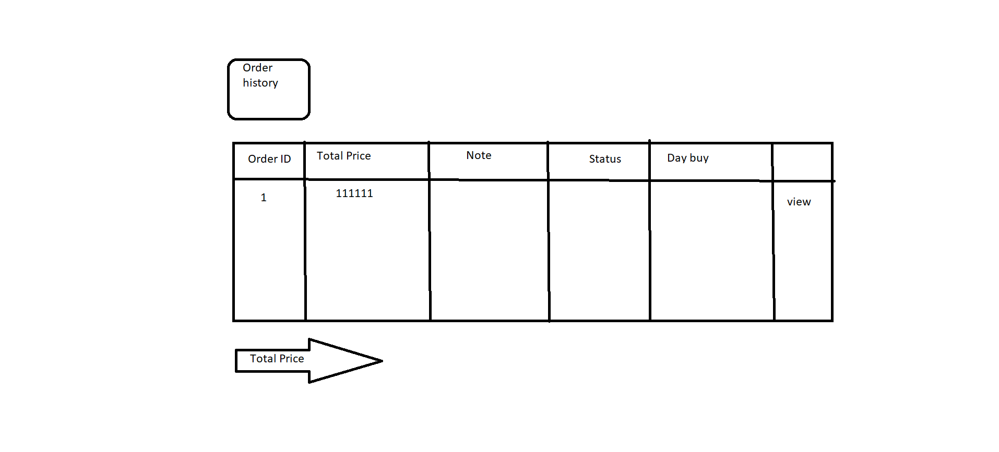

* 1. **Order Information**
* Function trigger: Users log-in to the website, access My Orders page and click View button
* Function description:
  + Role: Buyers
  + Purpose: See the order detailed information
* Screen layout:

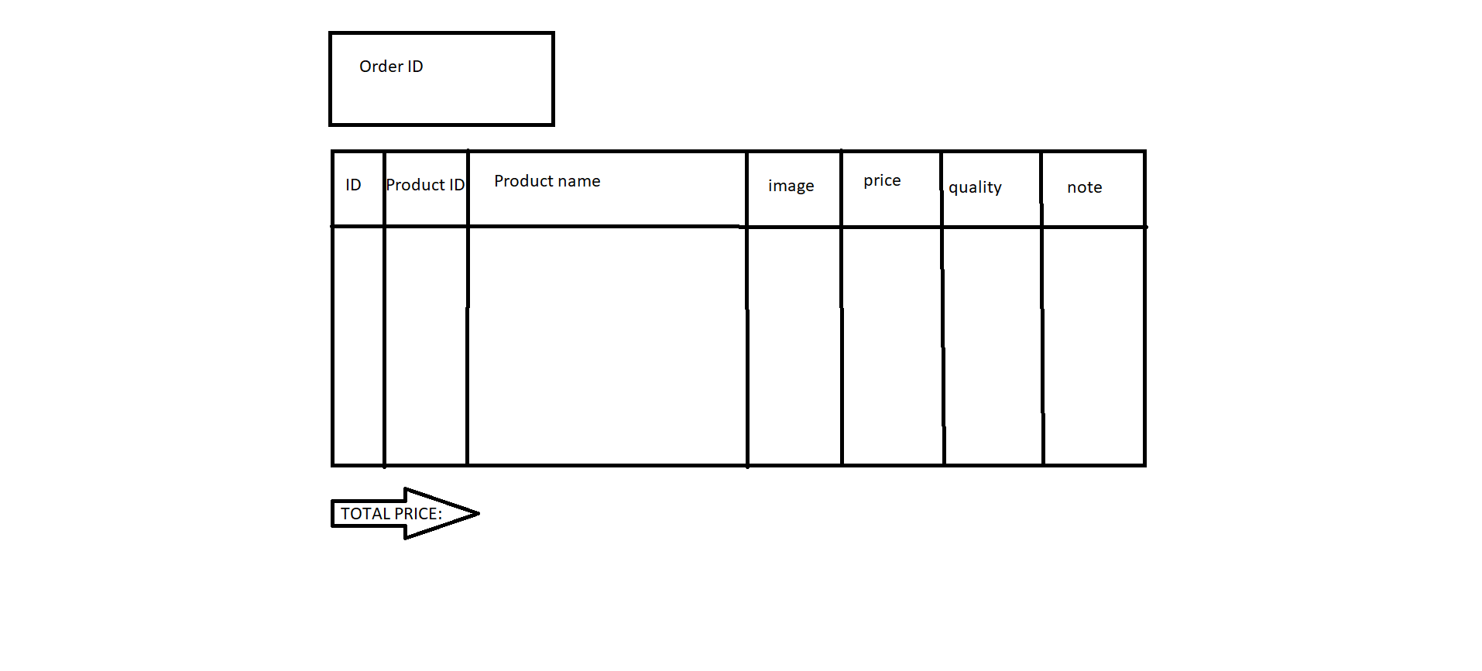

* 1. **View Product List**
* Function trigger: Users login as admin and click on Manage Product button or Product List button
* Function description:
  + Role: Admin
  + Purpose: Admin can manage the products of the website (add, delete, edit…)
* Screen layout

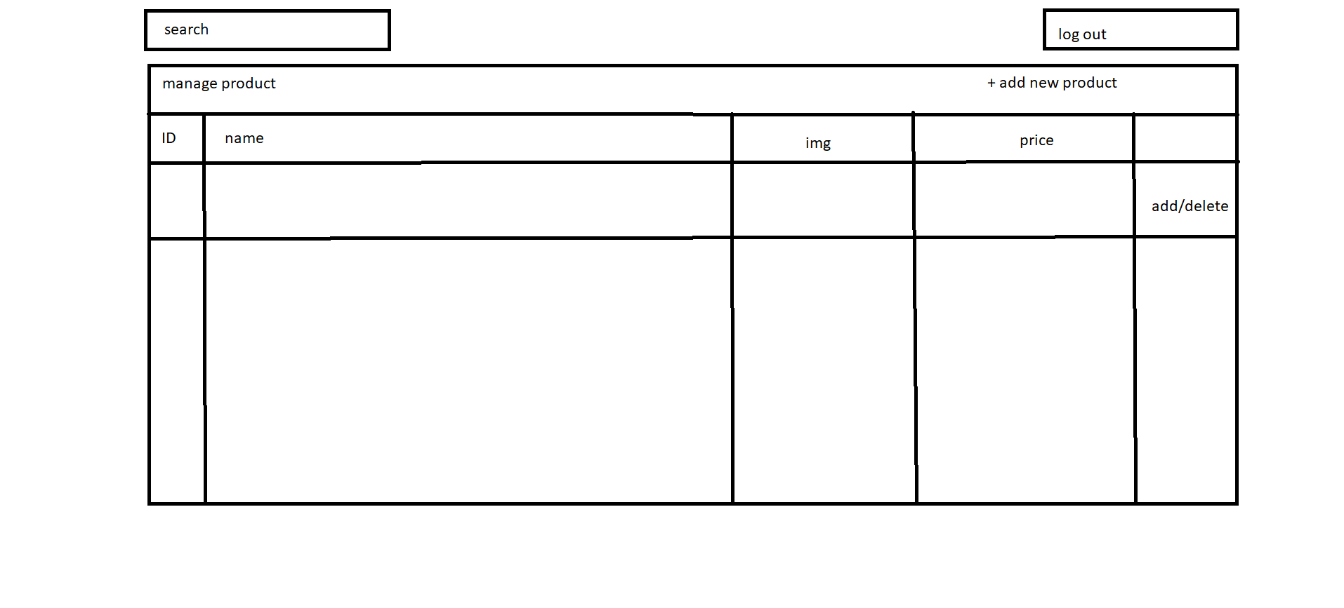

* 1. **Order List**

Function trigger: Admin Login and click Total Invoices

Function description:

• Role: Admin

• Purpose: Admin views list of all of 2orders

Screen layout:

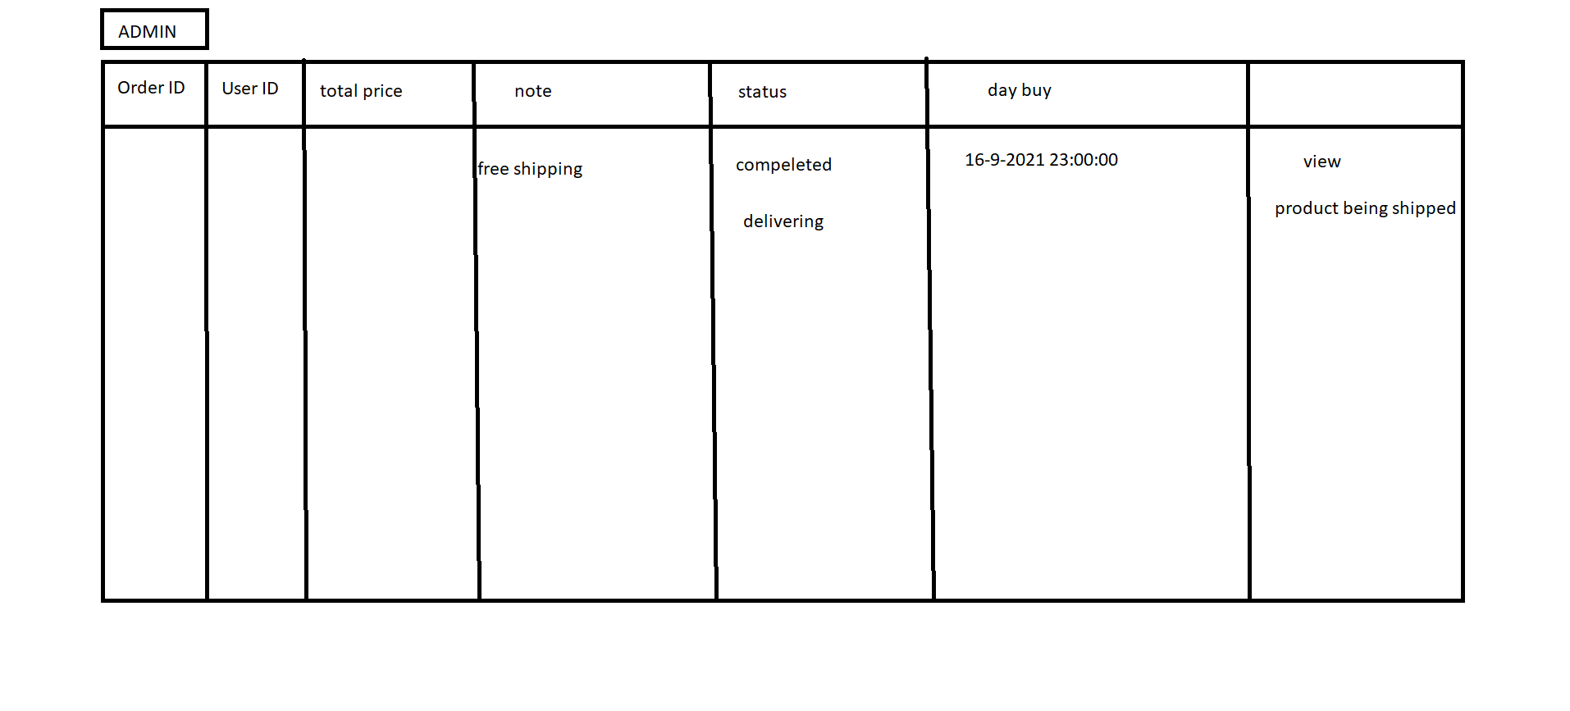

* 1. **Order Details**

Function trigger: Seller Login and click Total Invoices

Function description:

• Role: Seller

• Purpose: Seller views the detail of 1 of his orders

Screen layout:

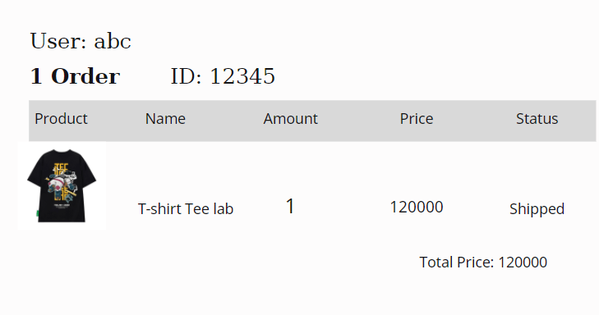

* 1. **View Feedback**

Function trigger: Customers click on the product they want to see, scroll down to see the feed back

Function description:

* Role: Guest, User
* Purpose: Customer views all the Feedbacks about a Product

Screen layout:

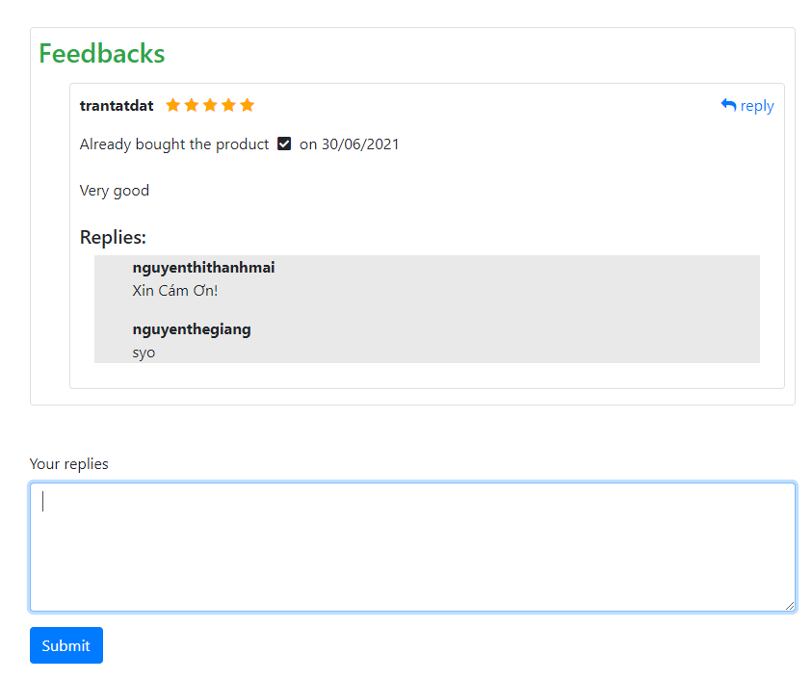

* 1. **Send Feedback**

Function trigger: When the user receives the goods, click on My order and then click on Add feed back and evaluate

Function description:

* Role: Guest, User
* Purpose: Customer writes and send a Feedback about a Product

Screen layout:

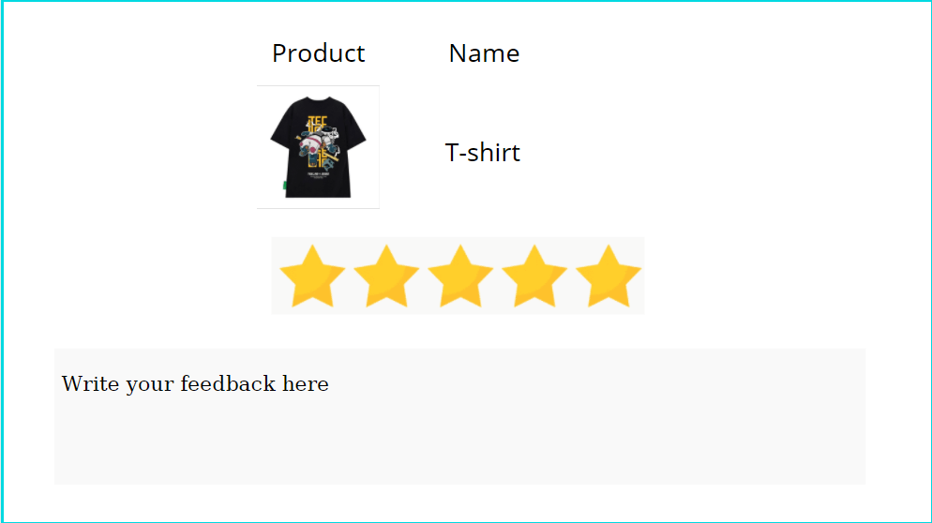

* 1. **Blogs List**

Function trigger: User Click Blog in menu bar

Function description:

* Role: Guest, User
* Purpose: Customer views the list of all Blogs

Screen layout: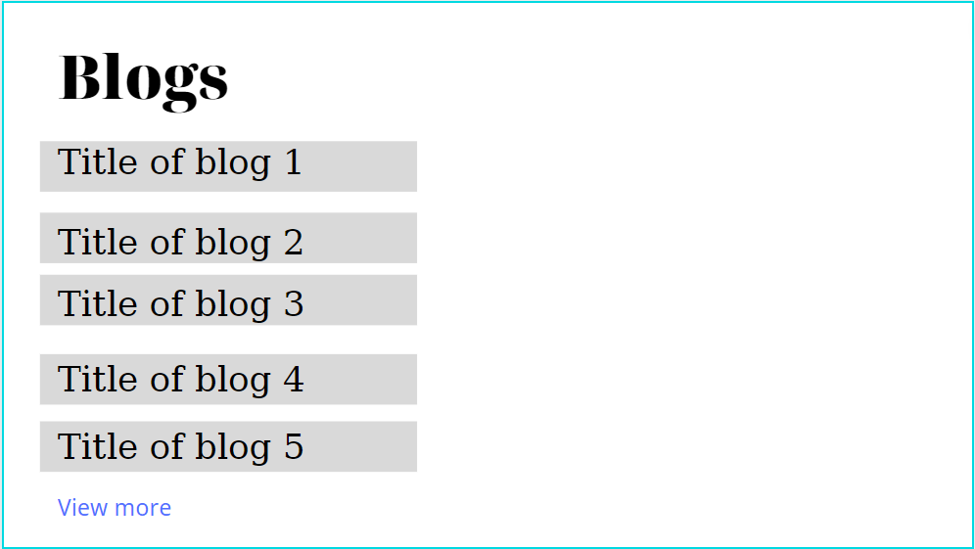

* 1. **Blog Details**

Function trigger: User Click Blog in menu bar. Next, click Blog want to see detail

Function description:

Role: Guest, User

Purpose: Customer views the Detail information of 1 Blog

Screen layout:

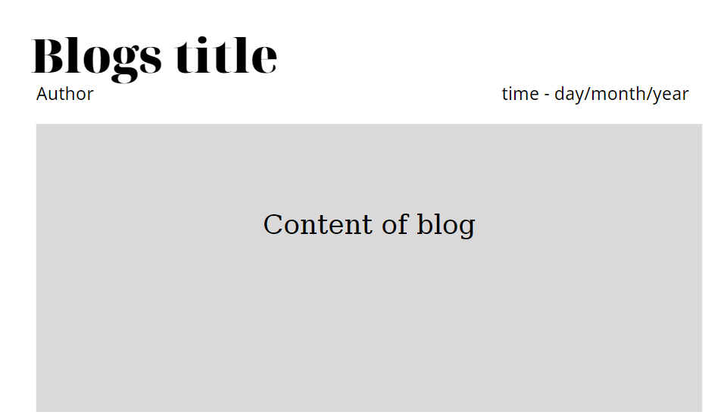

* 1. **View All Notifications**
* Function trigger: User logs-in the website, clicks on the bell and clicks on the “View all” link
* Function description:
  + Role: User, Seller, Admin
  + Purpose: User views the list of all Notifications
  + Screen Layout: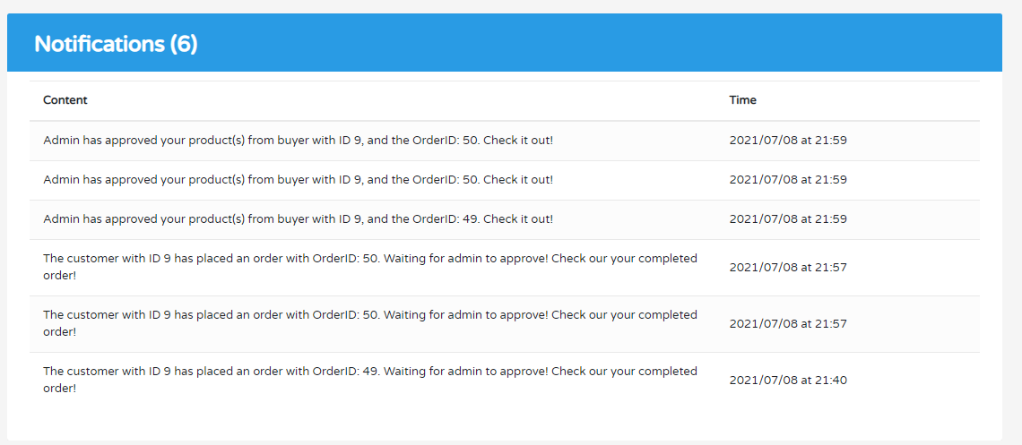
  1. **Mark as read**
* Function trigger: User logs-in the website, clicks on the text “Mark all as read”
* Function description:
  + Role: User, Seller, Admin
  + Purpose: User mark all the new Notification as read
* 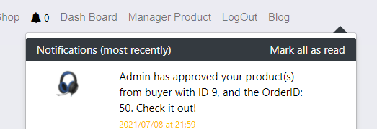Screen layout:
  1. **Error**
* Function trigger: User accesses the website, the website got an error
* Function description:
  + Role: Guest, User, Seller, Admin
  + Purpose: Show in case there’s an Error occurs
* Screen layout:

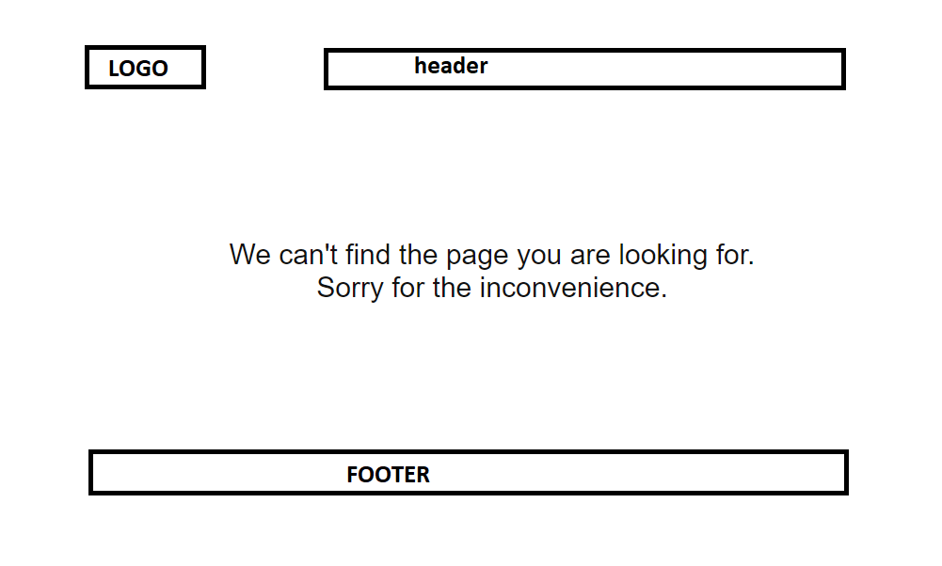

# 4. Data Requirements

## 4.1 Logical Data Model (Updating…)

## 4.2 Data Dictionary (Updating…)

## 4.4 Data Integrity and Retention

## Clothing Shop system will store customer orders so that when customers want to see what they bought last time.

## 5. External Interface Requirements

## 5.1 User Interfaces

## The Clothing Shop Ordering System screen displays shall conform to the User Interface Design and User Experience Design

## 5.2 Software Interfaces

+ Clothing Shop Account Checking system

+ Upload existing user data in the system through a programming interface

+ The system automatically checks what state the account is in in the UserStatus. If you belong to Locked, you will not be able to log in and have to create a new account, and if you belong to Unverified, you must go to gmail to verify your account.

+ Clothing System will transmit the quantities of product items ordered through a programmatic interface.

+ The Clothing system will display the quantity left in stock for the buyer. If there is no stock in stock, the user will not be able to place an order for this product.

## 5.3 Hardware Interfaces

No hardware interfaces have been identified.

## 5.4 Communications Interfaces

Clothing Shop shall send an email to the Customer to report any problems with the product order or delivery.

# Nonfunctional Requirements

## Performance Requirements

+ The system will provide continuous service, which means the shop will work 24/7, with an estimated average session duration of 30 minutes.

## Security

+ The website will use standard Web security protocols when transferring any private information regarding a Guest, Customer, or Seller.

+ Users will be required to log on to the Clothing Shop website for all operations except viewing home page, blog, product list and viewing a specific product.

+ Only the Admin will be permitted to confirm an order, only the Customer will be permitted to confirm an order has been delivered.

+ The system will permit Customer to view only orders that they placed and give a feedback on each products in those orders.

# Other Requirements

+ If the connection between the user and the Clothing Shop is broken prior to a new order being either confirmed or terminated, the Clothing Shop will enable the user to recover an incomplete order and continue working on it.

+ All confirmation code and order information will be send via user’s email.

+ The users email and user name cannot be changed.

# Appendix A: Analysis models

## Context Diagram

*GMAIL*

User email address, mail content

**ONLINE SHOP**

## State Transition Diagram for Order

